**"Flee the Field"**

**app name:** Flee the Field

**Bundle ID:** com.FleeTheField

**UI**:

<https://www.figma.com/file/D1zjk04Z3gSgqgZFmUWua8/Flee-the-Field?node-id=0%3A1>

**Sound**:

<https://drive.google.com/drive/folders/1SOA53CMrSWOuGcwZ6gfjuzOkmaK_VoRY?usp=sharing>

**UI Kit:**

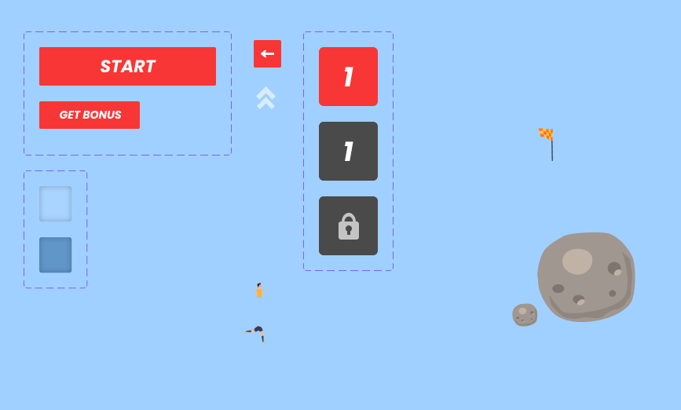

**Specifications:**

* operating system (OS): Android / Native
* screen orientation: vertical
* number of screens: 6
* languages: eng, ru

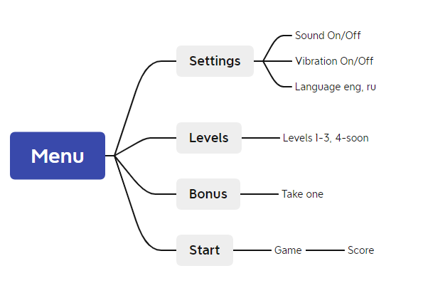

**Menu / Меню**

Buttons:

* Settings / Настройки - go to the settings section.
* Levels / Уровни - go to the levels section.
* Bonus / Бонус.
* Start / Старт - game start.

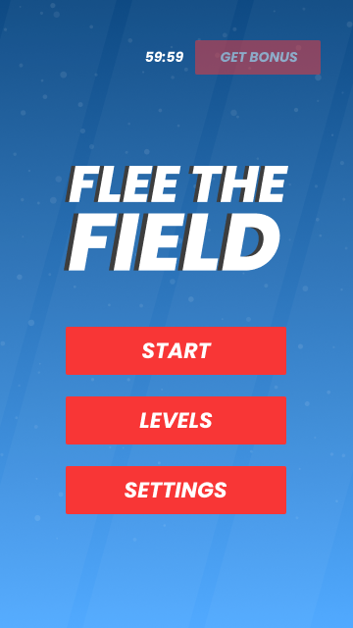

**Levels / Уровни**

Switches to a screen with levels. Three levels are displayed:

* 1st is open.
* The 2nd will open after passage of the 1st
* The 3rd level will open after the passage of the 2nd level
* The 4th is under a lock with the caption: "being planned” / “в разработке”

**Bonus / Бонус**

On the menu screen.

Tapping the "get" button gives you a bonus and starts the countdown for 24 hours.

You can have a maximum of 3 bonuses.

Bonuses are displayed on the gameplay screen.

**Settings / Настройки**

Buttons:

* On/Off Sound
* On/Off Vibration
* Language eng/ru
* Back to menu button

**Start / Старт**

Start of the game.

There is a playing field on the screen. The task of the player from the start is to get to the finish line (opposite end of the field) and not get caught by the referee.

The player can only move up/down and right/left via swipes anywhere on the screen. One move of the player, followed by one move of the opponent (playing with a bot).

At the bottom of the screen is a hint about the mechanics of the game: "Move with swipes.” / “Двигайся с помощью свайпов”.

One movement is one point in the scoring block, the fewer points, the better the level is passed.

There are 1 to 3 flags on the field in random locations that take 5 points off the total score, thus improving the stats. Each location is random.

At levels 2 and 3 there may be obstacles located on the field and occupying several cells at once, they cannot be collected, must be bypassed. Each time random placement.

Bonus tap: gives you the opportunity to make two turns in a row.

If the player is caught by the opponent, a short vibration is activated and the game ends. A window pops up with an offer to replay: “Replay” / “Переиграть” and the button to return to the menu: “Menu” / “Меню”.

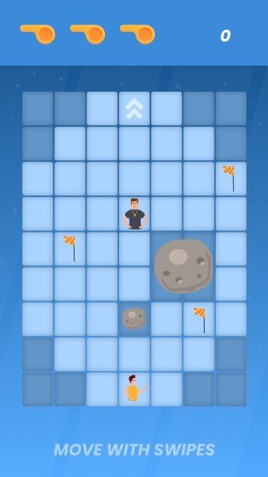

**Score / Итог**

After passing the first level a window pops up with the current result for the game and an offer to go to the next level: "Next Level" / "Следующий уровень" + button to return to the menu “Menu” / “Меню”. After passing the third level, there will only be a button to return to the menu.